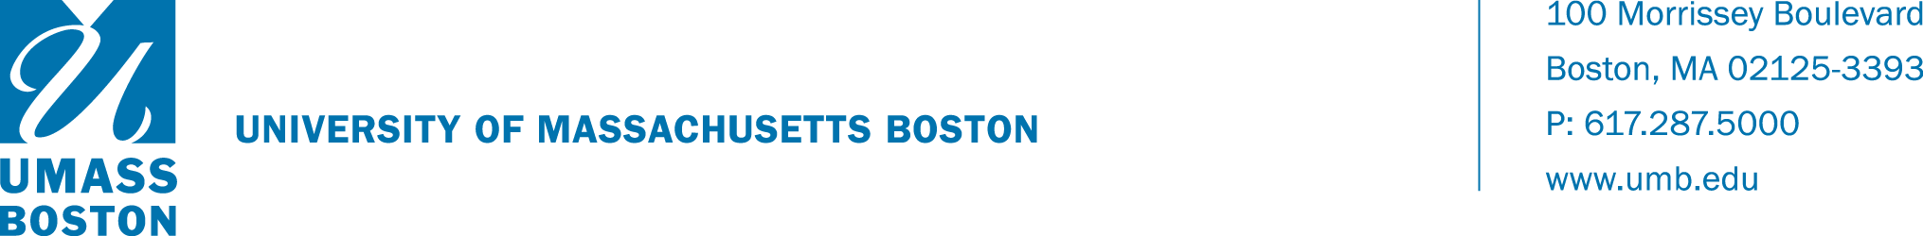

Date: October 22, 2020

To: Academic Deans

From: Emily McDermott, Interim Provost and Vice Chancellor for Academic Affairs

RE: Spring 2020 WISER Class Notes for Remote Courses

As we continue planning for the spring 2021 semester where will be utilizing remote instruction as our primary mode of delivery, we recognize that our students need information that can help them make their travel, living, and studying plans for the spring semester. One important piece of information they need is how their remote classes will be taught in the spring. We have found that the most effective way to communicate this information to students is via the Class Notes in the WISER system that appear together with the scheduling information for each class. These Class Notes are specific to each section listed in WISER.

To simplify this process for both students and faculty, we are using the process based on work done last summer by the Academic Continuity Task Force which devised nine ‘template’ Class Notes that are designed to cover the vast majority of courses offered this coming Spring. Using lessons learn from this summer, this document describes these six possible Class Notes (reduced from the nine variations used this summer and fall) and contains instructions for making a choice that is best for each instructor and their students. Once each choice has been communicated for a section, this information will be used by the registrar to enter the actual Course Notes into WISER.

Each course will be described in its Class Notes by two different parameters; one choice from the modality list (A, B, or C) and one choice from the technology list (1 or 2). Each instructor should make choices based on their judgement of what is best for the students in that class. The instructor should fill out and submit a separate version of the survey for every course for which they are responsible. The survey form can be accessed at this link (https://umassboston.co1.qualtrics.com/jfe/form/SV_1Fy0bJpSgjkl7aR ), please fill out by October 30.

The lists below show the exact text that will appear in the Class Notes on WISER. Following sections will provide detailed instructions for making your choice.
- Modality
  - The course will have synchronous meetings held at regularly scheduled class times. Attendance, or a way of making up any missed class time, will be required.
  - The course will be delivered primarily synchronous meetings with limited asynchronous components. Attendance at the synchronous sessions, or a way of making up any missed class times, will be required.
  - The course will be primarily or completely asynchronous with significant instructor engagement but there may be some non-required synchronous components with flexible times or a way of making up missed class time. This modality may only be used for remote courses with advance approval from the appropriate department chair, dean, and the provost.

- Technology
  - A Chromebook or an iPad Air/Pro will be sufficient to fully participate in the course. A laptop or desktop computer will be more than sufficient. Students without a Chromebook can request a loan from the university through this link: (https://www.umb.edu/life_on_campus/uaccess/chromebook_request_form).
  - The course requires specialized software, so a laptop or desktop computer will be required to fully participate in the course. A limited number of laptops are available for loan through this link (https://forms.office.com/Pages/ResponsePage.aspx?id=cYhxuekeJUSVPBrOE3PrOL6-CoKl1BJCvOaFb2ujpoVURFJGRkVBTTNTVUVKOVFFU0JaOFpRVjNMUy4u ).
Please work with your department chairs and instructors to fill out the form as soon as possible so that we can provide this useful information for our students as they are registering for classes. Please let Brian White know if you have any technical questions or let Joe Berger know if you have procedural questions. Thank you.

